**Assignment No. 2 (A)**

**Outputs:  
Step 1: Login to your Github account**

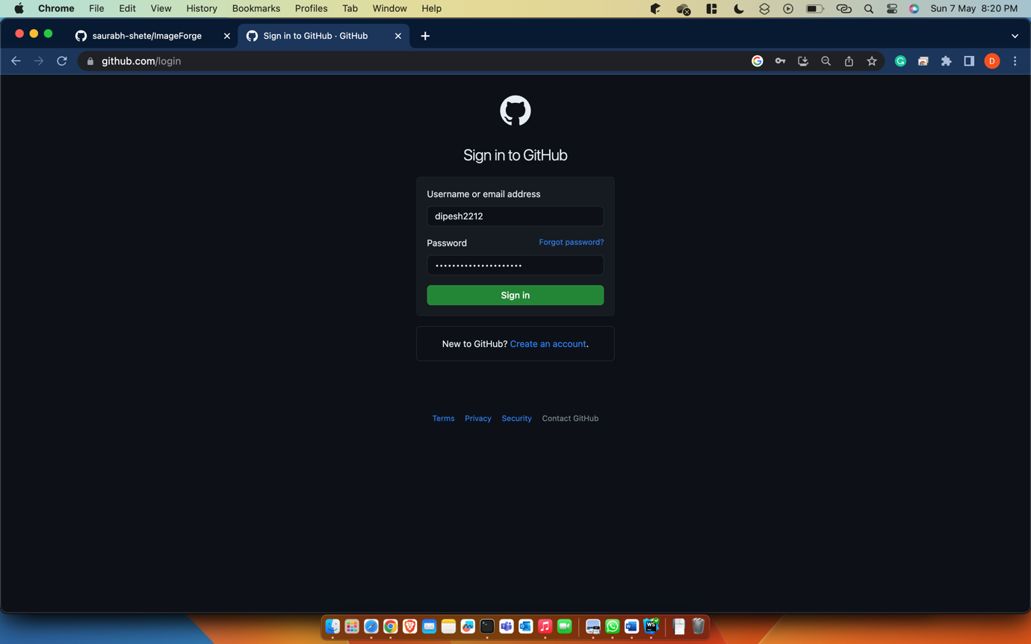

**Step 2: Create a New repository**

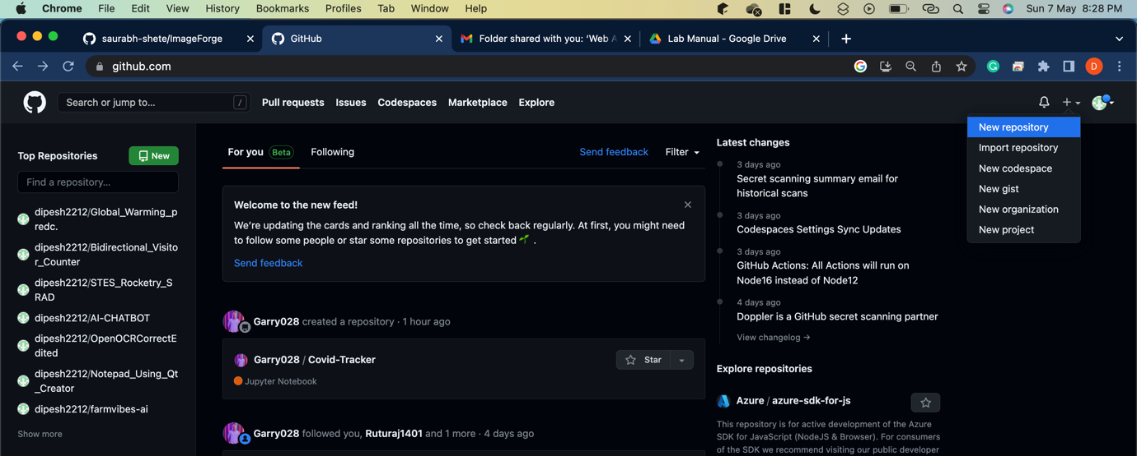

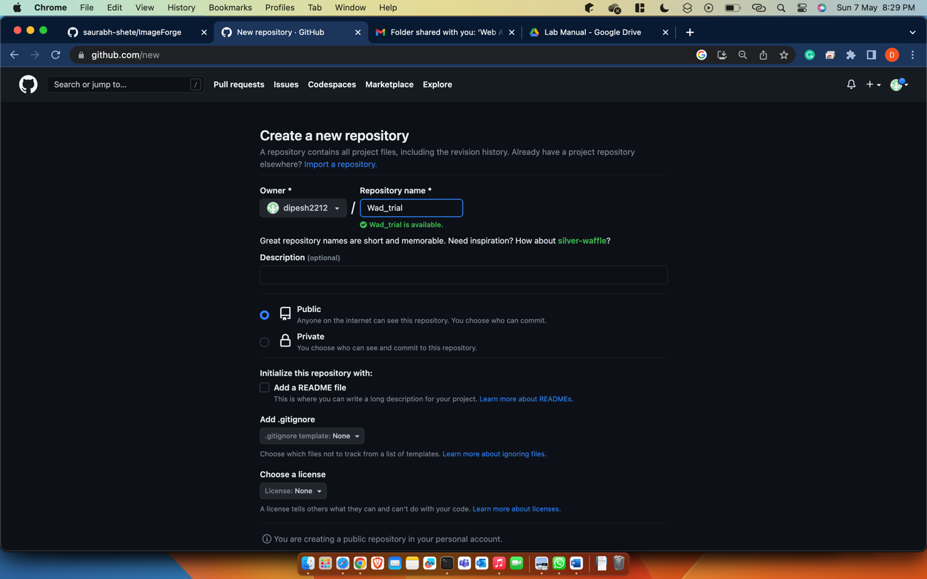

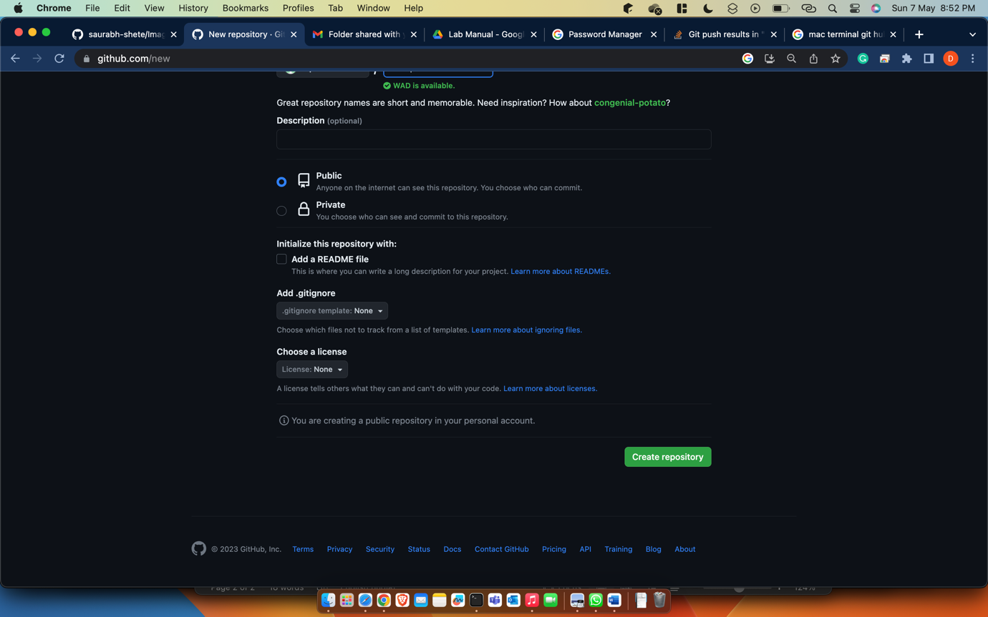

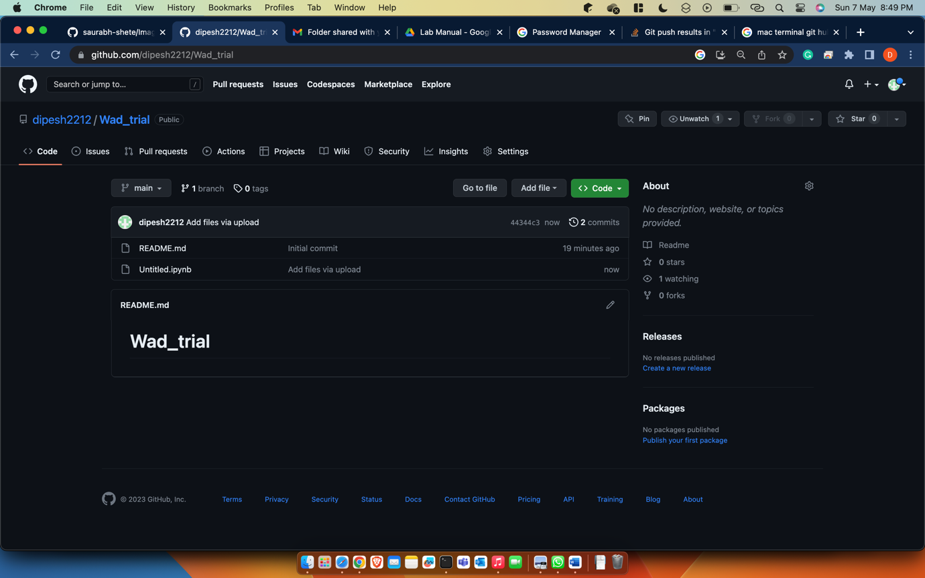

**Step 3: Add files to the repo using following commands**

1. **git init**
2. **git status**
3. **git add .**
4. **git commit -m “Initial Commit”**
5. **git remote add origin “Link-to-your-repo”**
6. **git push -u origin master**

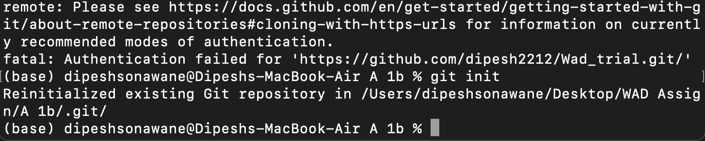

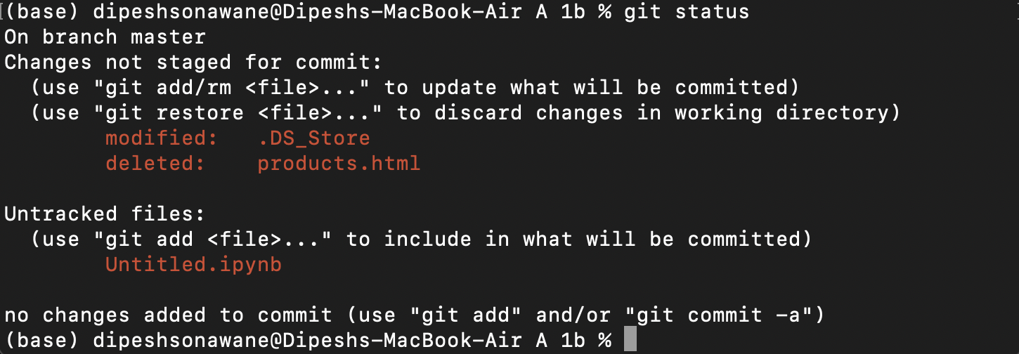

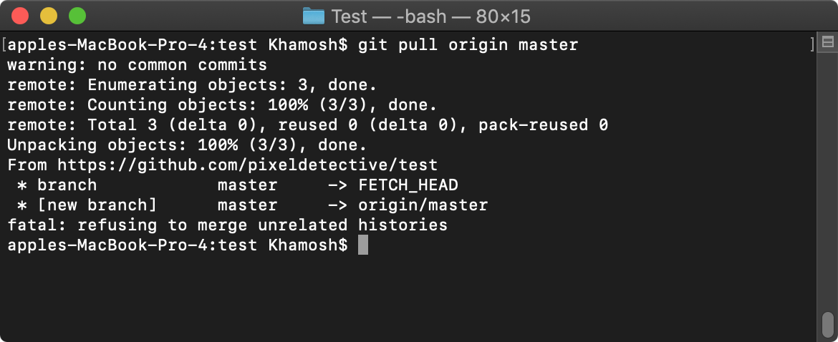

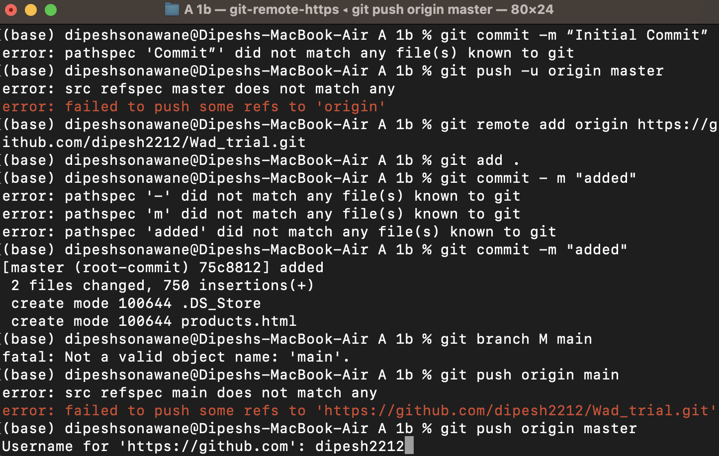

**Step 4: Check if file is added into your repo or not.**

